Why Choose Us

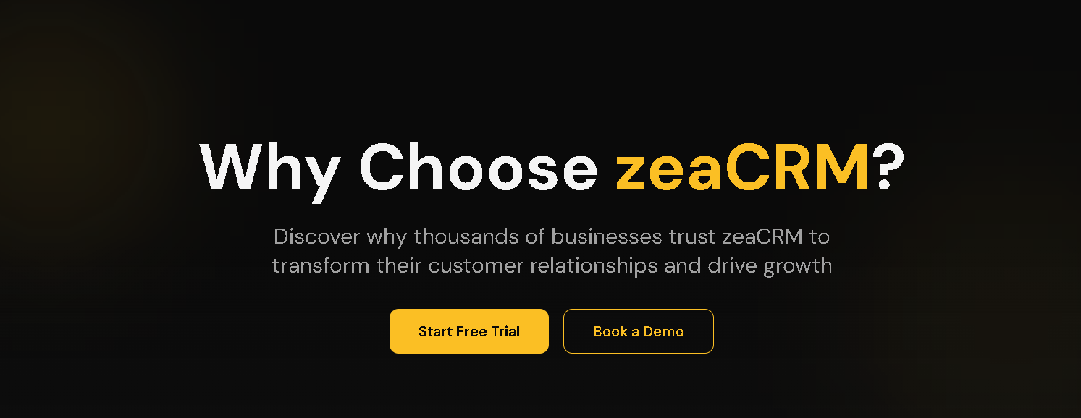

Why Choose ZeaCRM
Smarter. Faster. Proven.

Join 2,000+ businesses that automate their sales, marketing, and customer management with ZeaCRM. They are achieving up to 3x faster growth and 40% higher lead conversions through AI-driven automation. Are you ready?

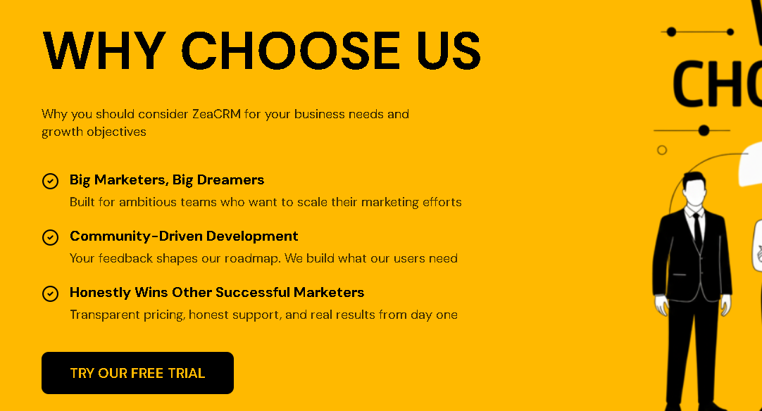

Why ZeaCRM Stands Out
Not just another CRM. ZeaCRM redefines how businesses build relationships and close deals with intelligent systems.

- AI That Works for You: Predictive insights and automation that handle the busywork so you can focus on results.
- Seamless Experience: One clean platform that brings sales, marketing, and support together.
- Scalable for Growth: From startups to enterprises, ZeaCRM grows with your business, not against it.

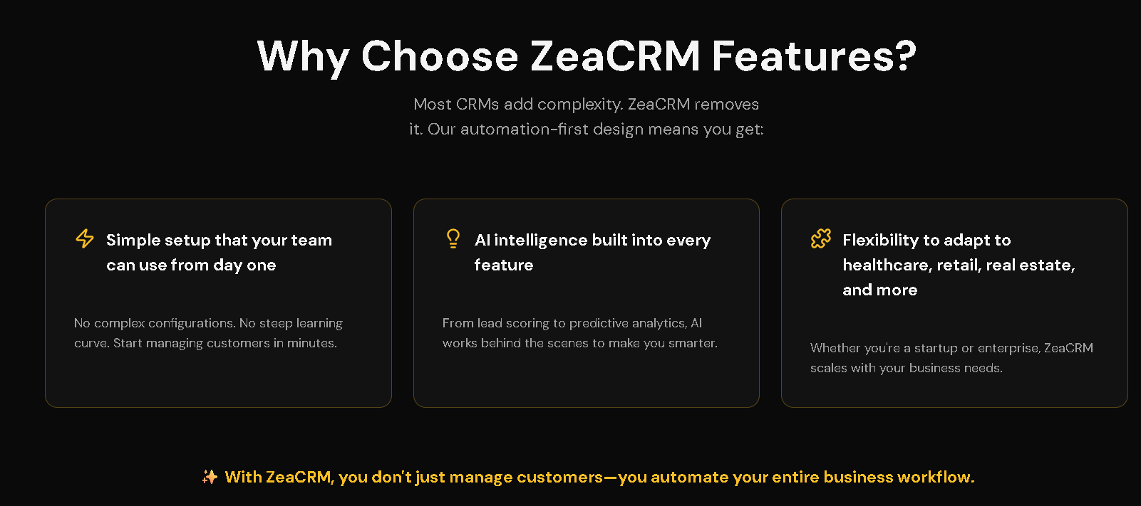

Powerful Features That Drive Performance
ZeaCRM combines smart automation, real-time analytics, and intuitive design to help you win faster.

- Smart Workflows: Automate follow-ups, reminders, and tasks to save hours every week.
- Unified Dashboard: Monitor leads, emails, calls, and deals in one easy view.
- Insight-Driven AI: Get recommendations on the next best action for every customer or lead.

All your team has to do is simplify, automate, and accelerate their growth by focusing on the tasks that matter.

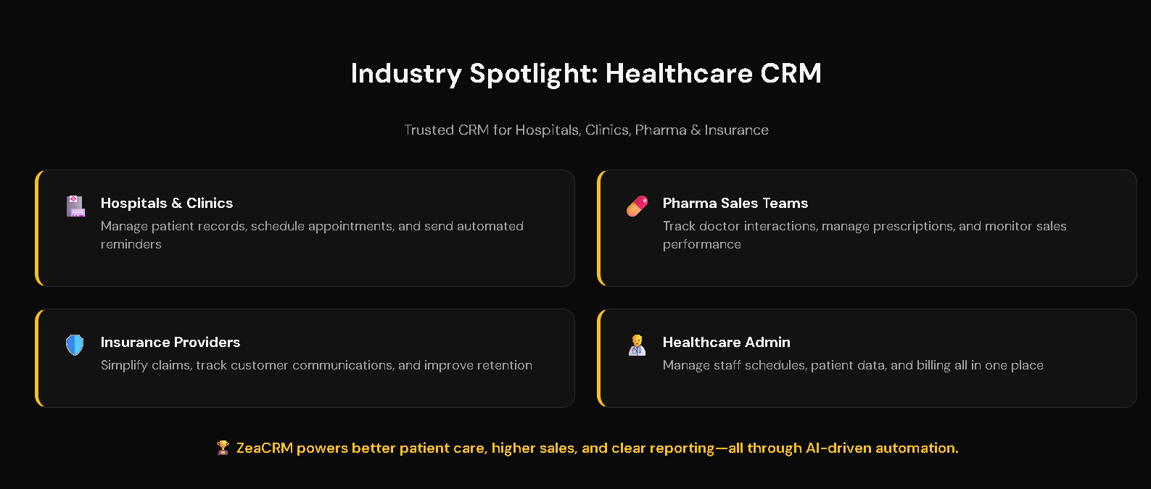

Industry Spotlight: Healthcare
ZeaCRM empowers hospitals, clinics, and healthcare professionals to deliver better patient experiences while improving efficiency and compliance.

Hospitals & Clinics
Manage patient records, schedule appointments, and send automated reminders.

Pharma Sales Teams
Track doctor interactions, manage prescriptions, and monitor sales performance.

Insurance Providers
Simplify claims, track customer communications, and improve retention.

Healthcare Admin
Manage staff schedules, patient data, and billing all in one place.

ZeaCRM powers better patient care, higher sales, and clear reporting. The best part is this is all through AI-driven automation.

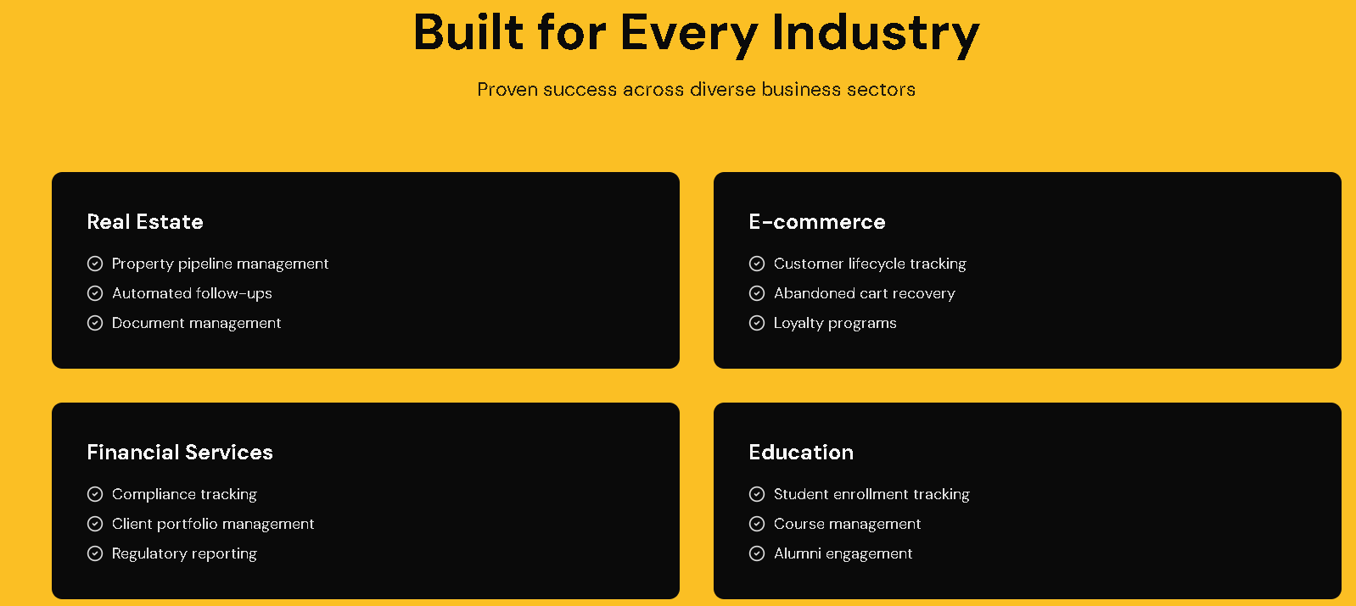

Built for Every Industry
One Platform, Limitless Possibilities

Real Estate
Capture, nurture, and close property leads faster with automated follow-ups and instant analytics.

Retail & E-Commerce
Deliver personalized campaigns, track customer purchases, and boost repeat sales effortlessly.

Finance & Insurance
Automate client onboarding, manage compliance data, and simplify follow-ups securely.

Education & Training
Track student inquiries, automate enrollments, and course communications efficiently.

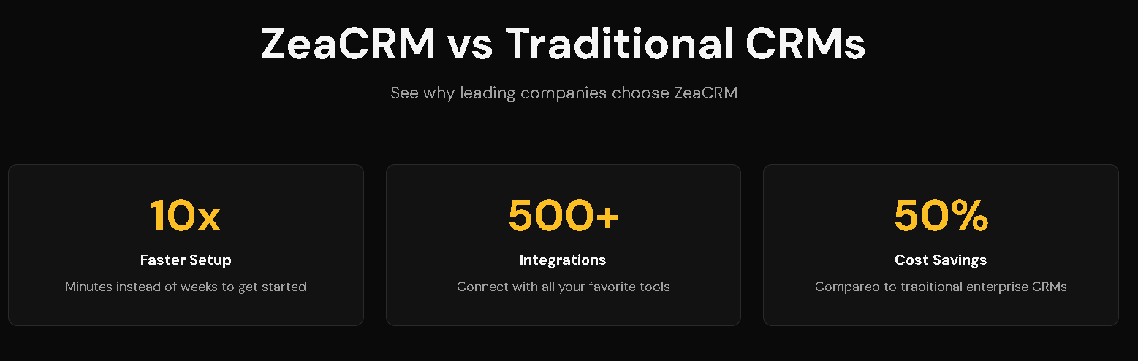

ZeaCRM vs Traditional CRMs
See Why Leading Companies Choose ZeaCRM

10x Faster Setup
Get started in minutes with our intuitive, AI-assisted dashboard

500+ Tools Integrated
Connect instantly with your favorite apps

50% Lower Cost
All features included with built-in smart workflows

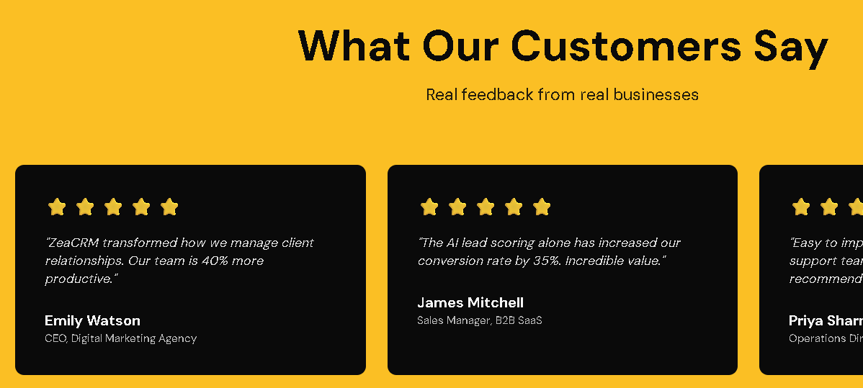

What Our Clients Say

“ZeaCRM is a true game-changer. We automated our follow-ups and saw a 35% jump in conversions within the first month.”

“The healthcare automation tools are incredible. Appointment scheduling and reminders run seamlessly now.”

“We switched from a legacy CRM and cut costs by half. ZeaCRM’s AI recommendations help us close deals faster.”

Features

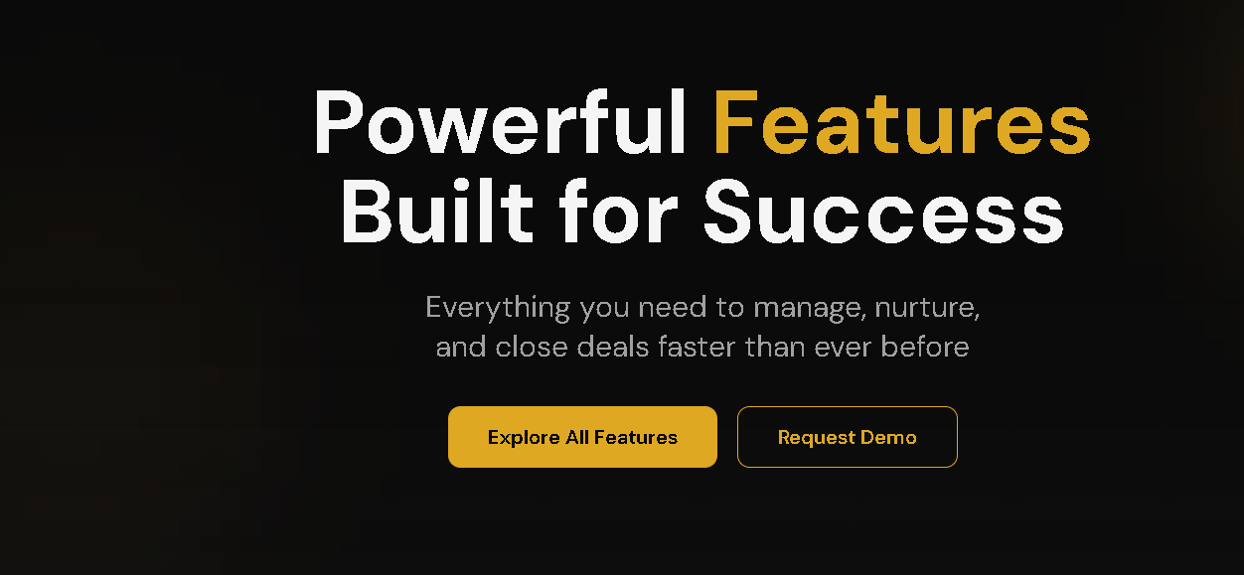

Work Smarter, Sell Faster, Grow Bigger
ZeaCRM gives you everything you need to automate workflows, manage relationships, and close deals. All in one intelligent, easy-to-use platform. Whether you’re a solopreneur or a growing enterprise, you’ll experience business agility powered by AI.

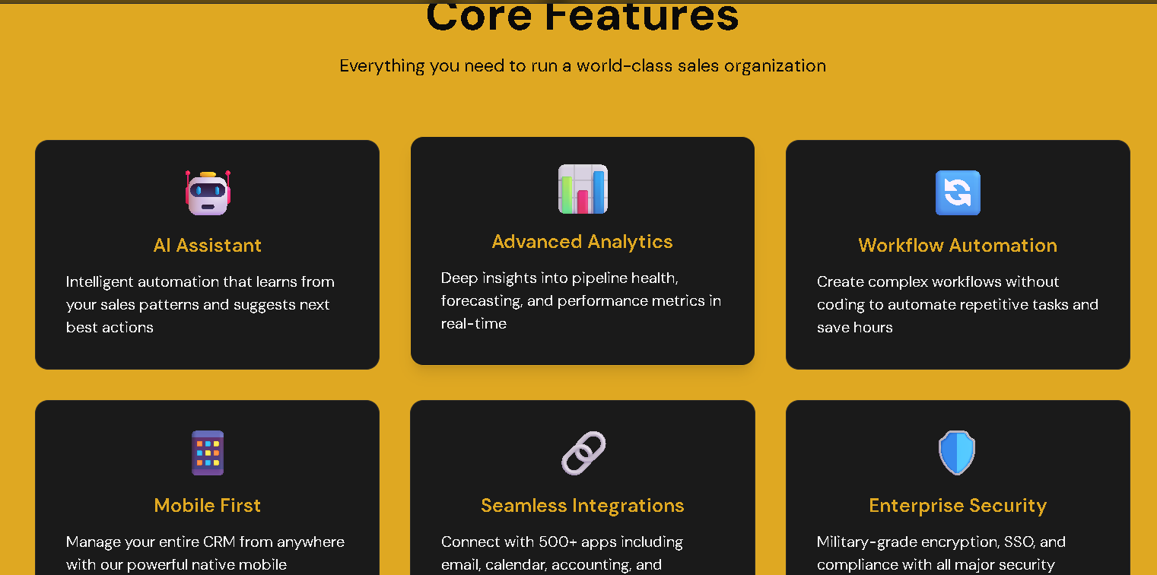

Core Features That Drive Growth
Here are some features that help your business thrive:

- CRM & Pipeline Management – Visualize every lead, deal, and opportunity in one clean dashboard.
- Email & Campaign Automation – Automate follow-ups and personalized sequences that convert.
- AI-Powered Recommendations – Get instant insights on who’s most likely to close next.
- Workflow Automations – Save time with trigger-based tasks and reminders.
- Analytics Dashboard – Track performance, conversion trends, and sales health in real time.
- Mobile CRM – Access your data, deals, and updates on the go anytime, anywhere.

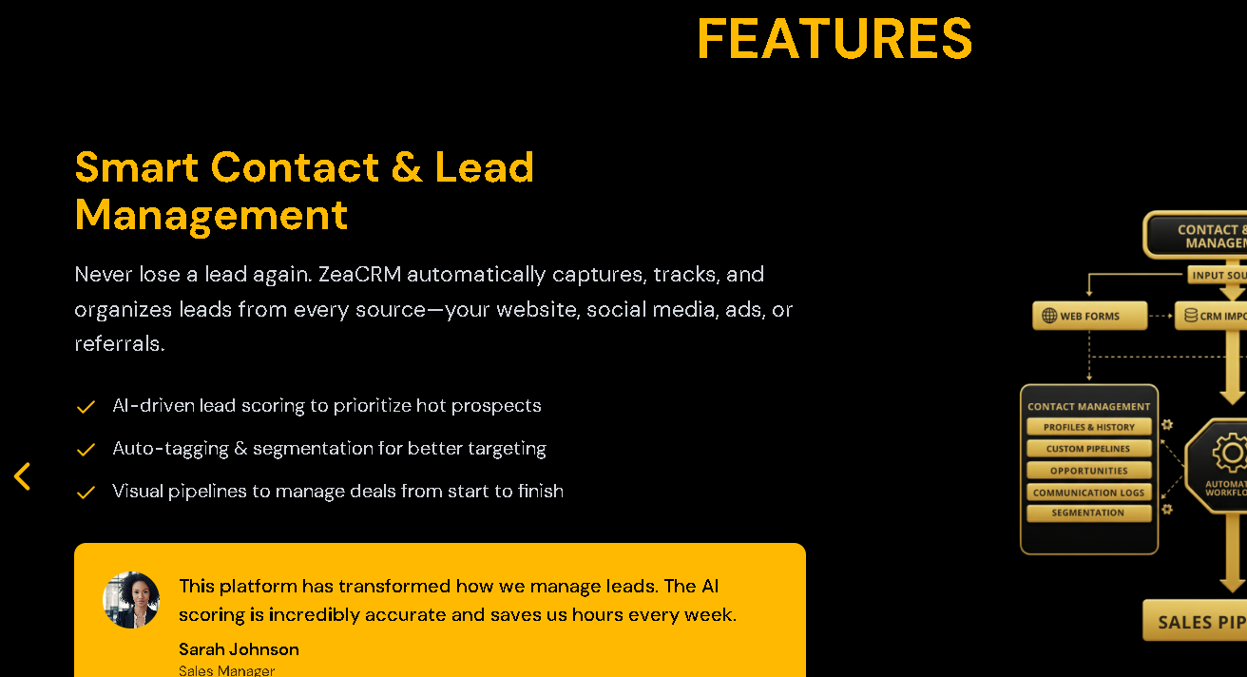

More Features You’ll Love
- Smart Contact & Lead Management – Capture, qualify, and prioritize leads effortlessly.
- Custom Sales Pipelines – Design pipelines that match your exact workflow and goals.
- Team Collaboration Tools – Assign, comment, and update deals in real time.
- 2-Way SMS & Email Sync – Keep every customer conversation in one place.
- Appointment Booking – Let leads schedule calls or demos automatically.
- Customer Segmentation – Target your audience with precision for every campaign.
- File & Document Sharing – Upload proposals, contracts, and notes directly to client profiles.
- Revenue Forecasting – Predict upcoming sales and plan smarter with AI insights.
- Task & Reminder Automation – Never miss a deadline with smart follow-ups and alerts.

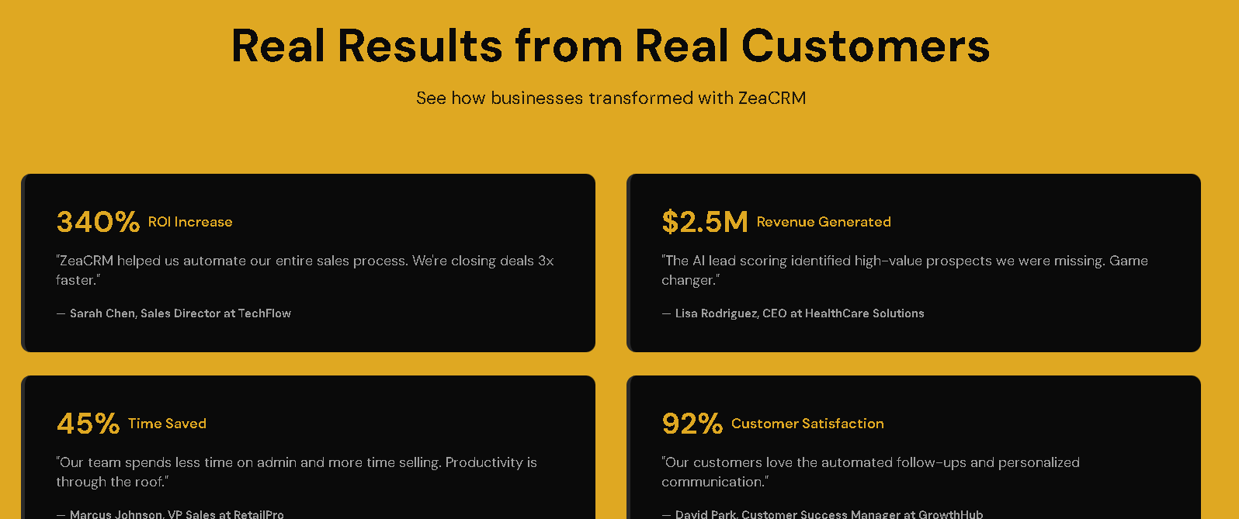

What Our Users Say

“ZeaCRM made our team 3x more efficient. The automation alone saves us nearly 10 hours a week.”

“It’s the only CRM that actually fits how we work. Custom pipelines are a game-changer.”

“From lead capture to follow-up, everything just flows. ZeaCRM is my daily growth engine.”

“We run our entire customer lifecycle from one dashboard now. The insights are gold.”

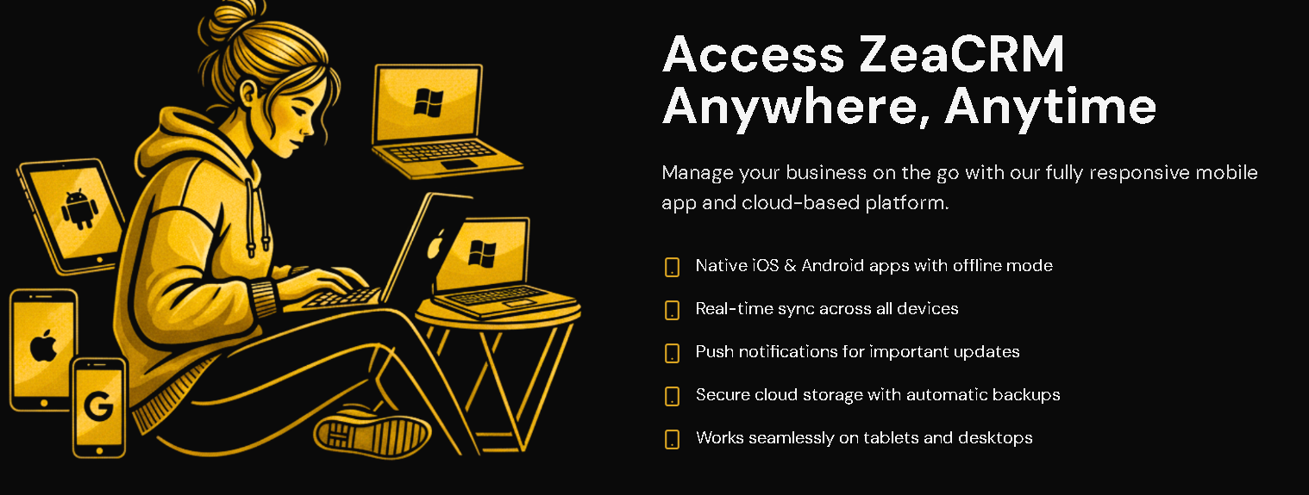

Stay Connected, Wherever Business Takes You
Your sales never sleep and neither does ZeaCRM. Manage your customers, monitor performance, and collaborate with your team from any device.

- 100% cloud-based platform for secure remote access
- Works on desktop, tablet, and mobile
- Real-time notifications and updates
- Offline mode for essential functions
- Data auto-sync across all devices
- Role-based permissions for team control

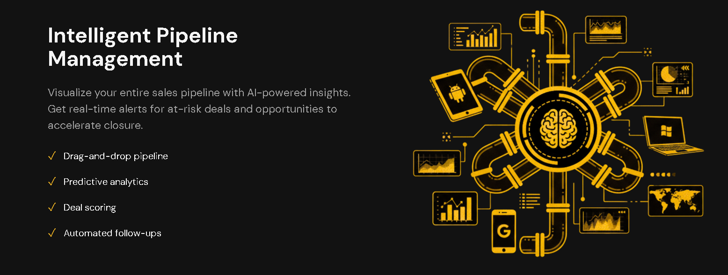

Intelligent Pipeline Management
ZeaCRM turns your sales pipeline into a visual growth engine. Every stage, every lead, and every opportunity is managed intelligently with AI insights. With drag-and-drop simplicity and predictive analytics, your team always knows what to do next.

- Track and update deal stages in real time
- Get AI recommendations on high-value leads
- Automate stage-based tasks and follow-ups
- Forecast revenue and conversion trends instantly

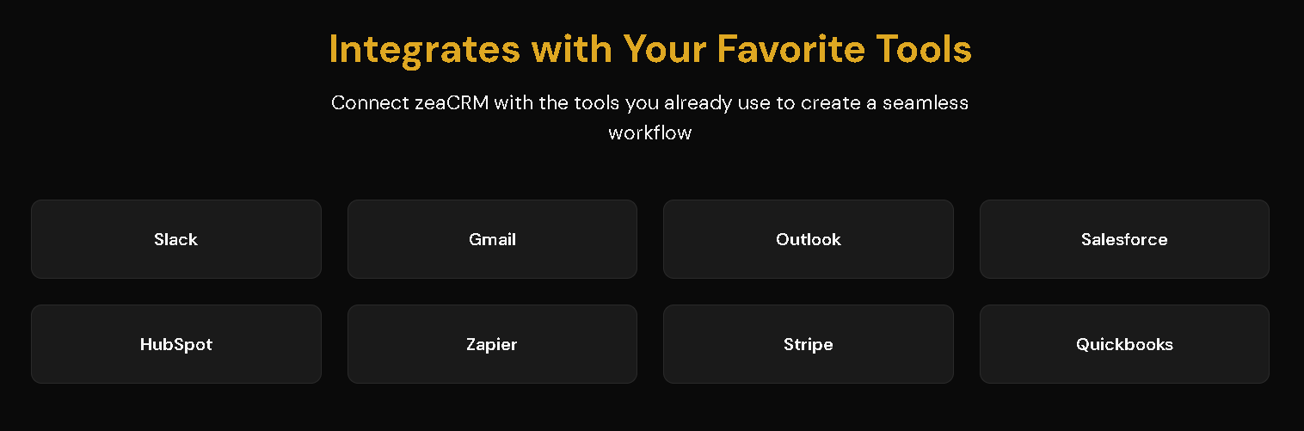

ZeaCRM Plays Well with Everything You Use
Connect your workflows seamlessly. No switching tabs or juggling logins. ZeaCRM syncs with leading business apps for effortless collaboration.

- Slack
- Microsoft Outlook
- Gmail
- WhatsApp Business
- Google Calendar
- Zapier
- Zoom
- HubSpot

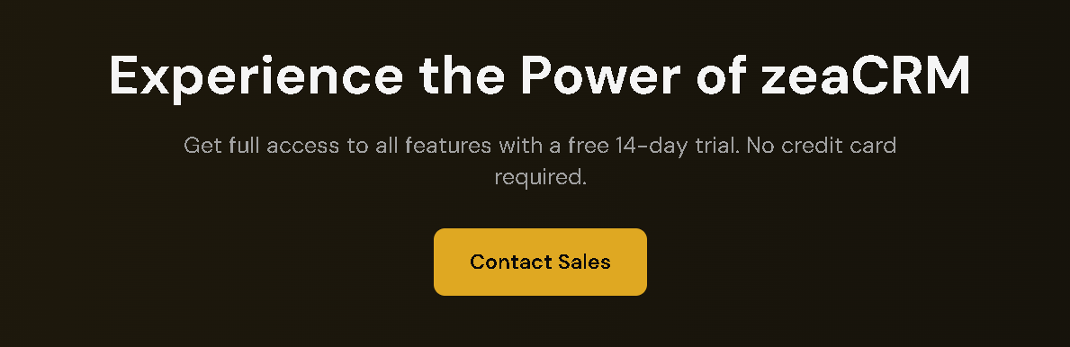

We’re Here for You
Our support and onboarding specialists are ready to guide you every step of the way from setup to success.

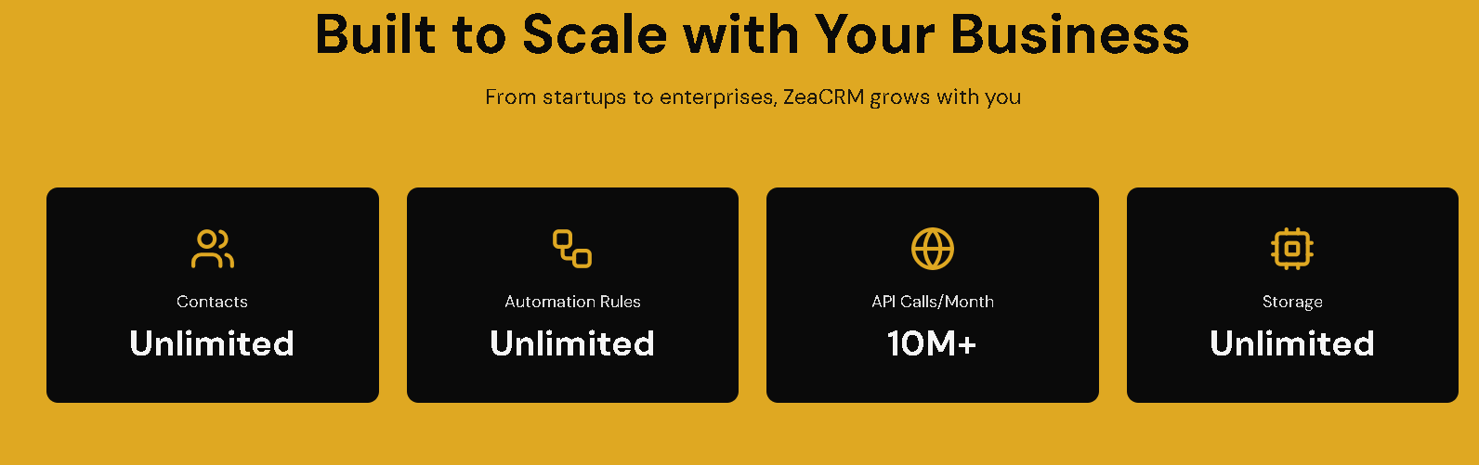

Built to Scale with Your Business
ZeaCRM evolves with you. Whether you’re closing your first deal or scaling into new markets, we are with you every step of the way.

- Unlimited Contacts & Pipelines – Expand your database without extra cost.
- Multi-Team Access – Add departments and manage permissions easily.
- Advanced Custom Fields – Tailor data tracking to your unique business needs.
- High-Speed Performance – Handle thousands of leads without slowdown.

